CALL CENTER VOICE AGENT - CASE STUDY
Enterprise Voice Intelligence for Contact Center Transformation
________________________________________________________________________________
1. PROBLEM STATEMENT (Data-Driven)
• Industry / Customer Context:
- A leading multi-vertical enterprise serving customers across banking, healthcare, hospitality, and government services. Their business operations spanned customer support, appointment scheduling, collections, and information services, handling millions of voice interactions monthly across India's linguistically diverse markets.
• Core Problem Identified:
- Traditional IVR and human agent model could not scale intelligence without proportional cost increases. Their hybrid approach combined legacy IVR systems with large human call center teams supported by basic AI transcription tools, creating a fundamental capacity-versus-quality trade-off that made growth economically unviable.
• Supporting Data Points:
- Staffing costs consumed 40-60% of operational budgets, unsustainable at projected growth rates
- Average wait times of 45-90 seconds during normal hours, significantly higher during peak periods
- Peak-hour call volumes regularly exceeded capacity, leading to queue abandonment and direct revenue leakage
- Human script adherence accuracy ranged 70-85% due to knowledge gaps and script deviation
- Multilingual support required specialized regional teams for each language, creating operational silos
- Legacy IVR systems offered zero autonomous resolution; all calls required human handoff after menu navigation
- Off-the-shelf conversational AI tools remained assistive copilots requiring human supervision, not autonomous agents
• Why It Mattered:
- Revenue risk: Call abandonment during peak hours resulted in direct revenue leakage and wasted customer acquisition costs
- Compliance exposure: Inconsistent policy adherence and disclosure practices created regulatory risk in banking and healthcare verticals
- Scalability ceiling: The business needed to handle 10x call volume growth without proportional staffing increases, impossible with existing infrastructure
- Competitive disadvantage: Inability to offer 24/7 multilingual support limited market expansion into underserved linguistic regions
- Customer trust erosion: Long wait times, inconsistent service quality, and limited operating hours damaged brand reputation
________________________________________________________________________________
2. IMPACT OF THE PROBLEM (Functional, Emotional & Social Pain)
• Operational Pain:
- Team burnout: Call center staff experienced high stress from repetitive, high-volume interactions with limited decision authority
- Manual effort waste: Agents spent 4-6 minutes per call for simple appointment scheduling and 2-3 minutes for basic information lookup, time consumed by system navigation rather than customer service
- Coverage gaps: 24/7 operations required expensive night-shift premiums and weekend staffing, while still leaving service gaps during regional holidays
- Quality inconsistency: Training cycles took 3-6 weeks per agent, with knowledge decay requiring constant reinforcement
- Capacity bottlenecks: Marketing campaigns and seasonal demand spikes created unpredictable volume surges, requiring emergency overstaffing or accepting abandoned calls
• Emotional Impact:
- Leadership stress: Operations managers firefighting daily crises around staffing shortages, quality failures, and compliance near-misses
- Lack of visibility: No real-time insights into conversation quality, sentiment trends, or root-cause issues; management flying blind on performance
- Customer frustration: Callers experienced long wait times, repeated explanations due to poor CRM logging, and inconsistent answers depending on which agent they reached
- Agent demoralization: High-performing staff felt underutilized handling routine queries, while struggling agents faced negative feedback loops
• Social / Organizational Consequences:
- Cross-team friction: Regional teams operated in silos due to language specialization, preventing knowledge sharing and unified quality standards
- Customer dissatisfaction: Net Promoter Score (NPS) erosion from wait times and service inconsistency, with negative reviews citing accessibility issues
- Reputational risk: Social media complaints about unavailable support and poor multilingual service damaged brand perception in regional markets
- Talent retention challenges: Call center turnover rates exceeded industry averages due to repetitive work and burnout
• Cost of Inaction (quantified):
- Linear scaling costs: Projected 10x volume growth would require proportional hiring, adding Rs 15-25 Cr annually in personnel costs plus infrastructure
- Revenue ceiling: Inability to serve after-hours and multilingual customers would cap addressable market at current size despite demand growth
- Compliance penalties: Continued human error in regulated industries risked fines, audits, and license restrictions
- Competitive obsolescence: Competitors adopting autonomous AI would gain cost advantages of 60-75%, making pricing uncompetitive
________________________________________________________________________________
3. SOLUTION PROVIDED (Pain Relievers & Gain Creators)
• Solution Overview (1-2 lines):
- Adya AI Voice Platform is an enterprise-grade multi-agent system for autonomous voice interactions that replaces both legacy IVR systems and human agent dependency with intelligent, context-aware AI agents handling complete customer interactions from call pickup to resolution.
• Key Features Implemented:
- Feature 1: Multi-Agent Orchestration Architecture - Pain Relieved: Eliminates human dependency for routine interactions
- Coordinated system of specialized agents (STT for speech recognition, LLM for dialogue and intent understanding, TTS for speech synthesis, telephony orchestration for call management, knowledge retrieval for context) working together with sub-200ms latency to enable natural conversations.
- Impact: Fully autonomous conversations from greeting to resolution, no human required for 80-90% of routine inquiries
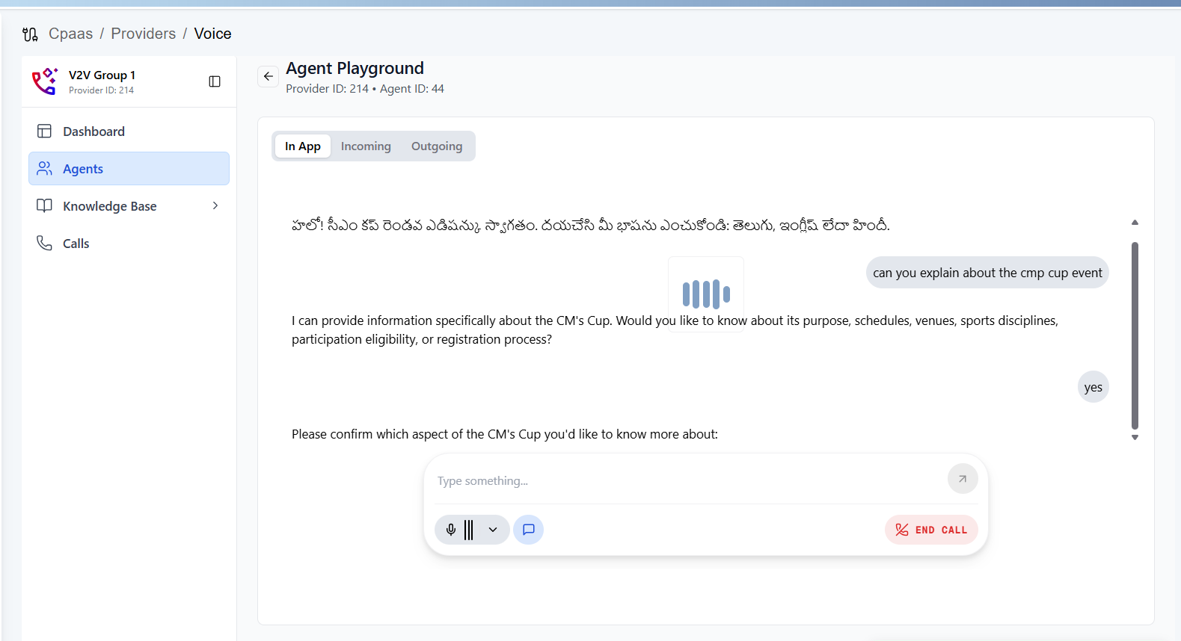
- Feature 2: Multilingual Real-Time Processing - Gain Created: 40% market expansion
- Real-time support for 12+ Indian languages plus English with provider failover based on automatic language detection. Voice selection for regional accents, gender, and tone matching brand identity. Same-day deployment capability for new languages without regional hiring.
- Impact: Launched services in 8 additional languages (Tamil, Telugu, Kannada, Bengali, Marathi, Gujarati, Malayalam, Punjabi) previously unsupported, expanding addressable customer base by 40%
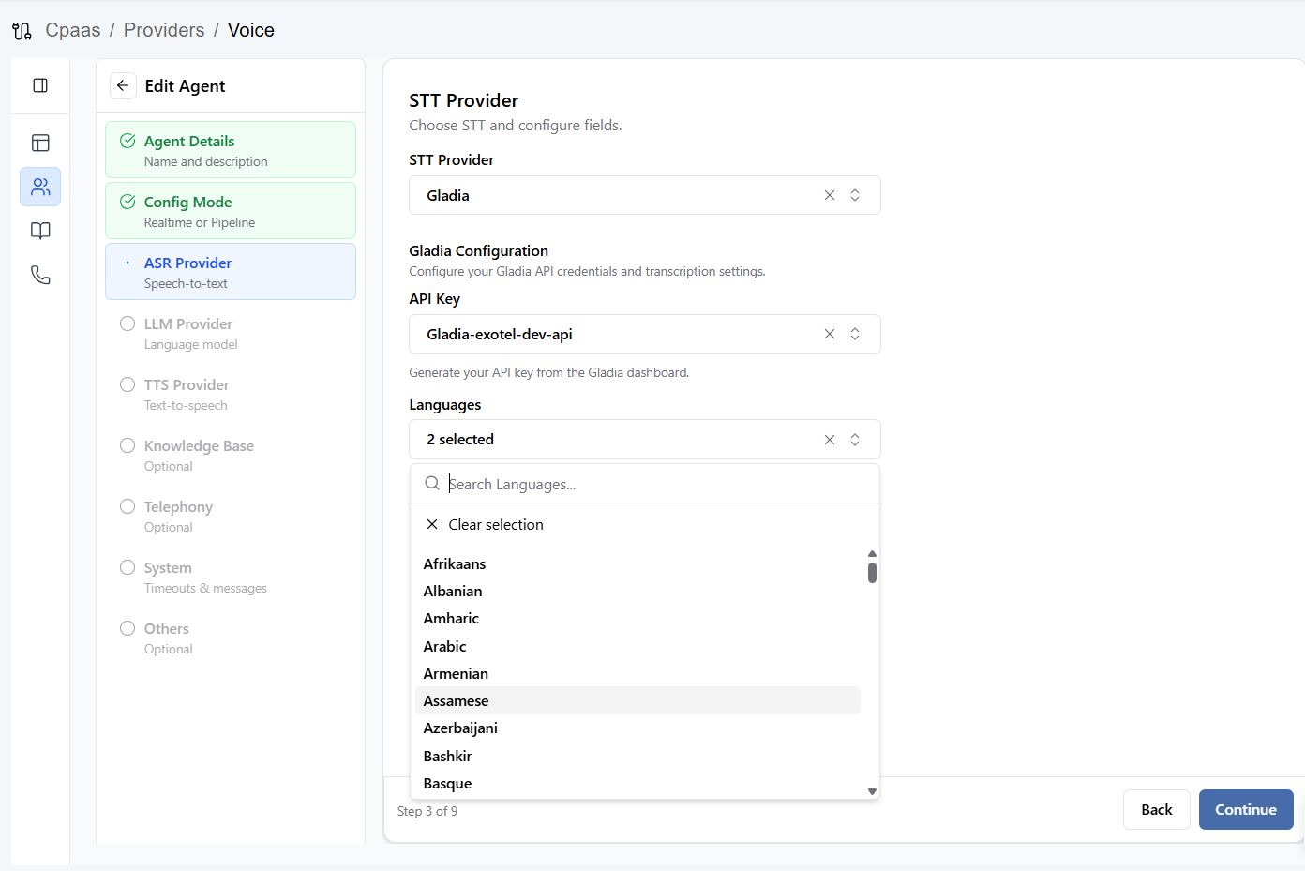
- Feature 3: Owned Intelligence Infrastructure - Efficiency and Governance Impact
- Full operational control with agents running in client cloud/VPC (data never leaves security perimeter). Swappable STT, LLM, TTS, and telephony providers based on cost, performance, or compliance needs. BYOK (Bring Your Own Keys) for complete cost transparency. Business rules and compliance policies configured by client without vendor mediation.
- Impact: Eliminated vendor lock-in, achieved regulatory compliance for banking and healthcare, reduced per-interaction costs by 60-75%
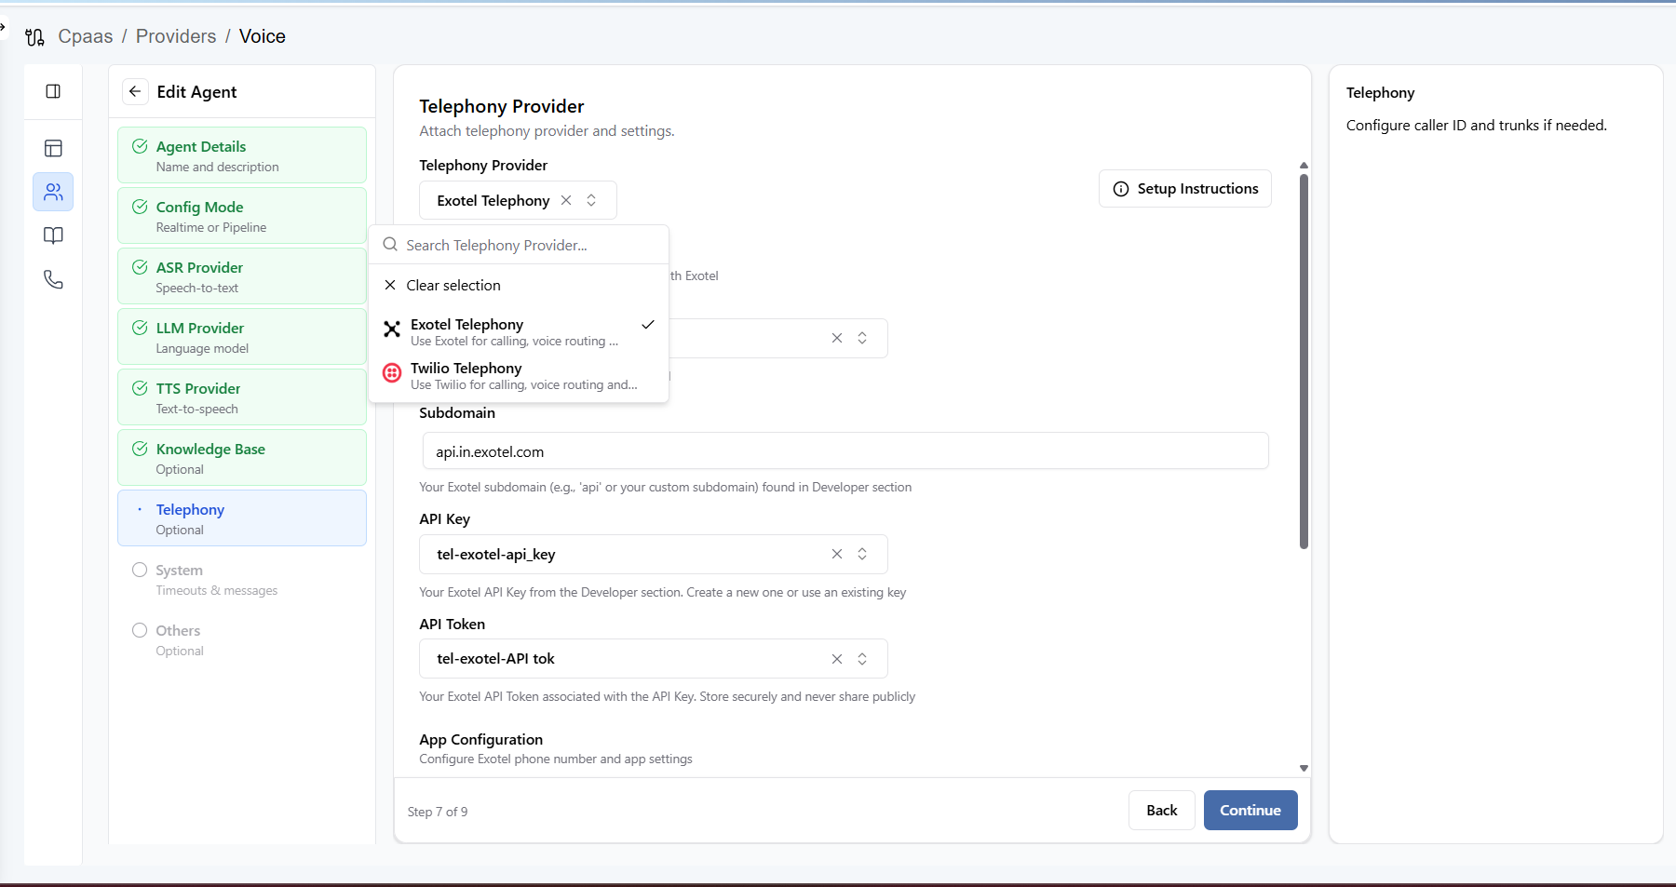
- Feature 4: Real-Time Knowledge Base Integration - Gain Created: 95%+ response accuracy
- Vector database integration with automatic document vectorization (up to 10MB files). Real-time context retrieval from FAQs, policies, and product catalogs with sub-second latency. Automatic knowledge base updates without downtime or retraining.
- Impact: Response accuracy increased to 95%+ versus 70-85% with human agents, with consistent policy adherence across all interactions
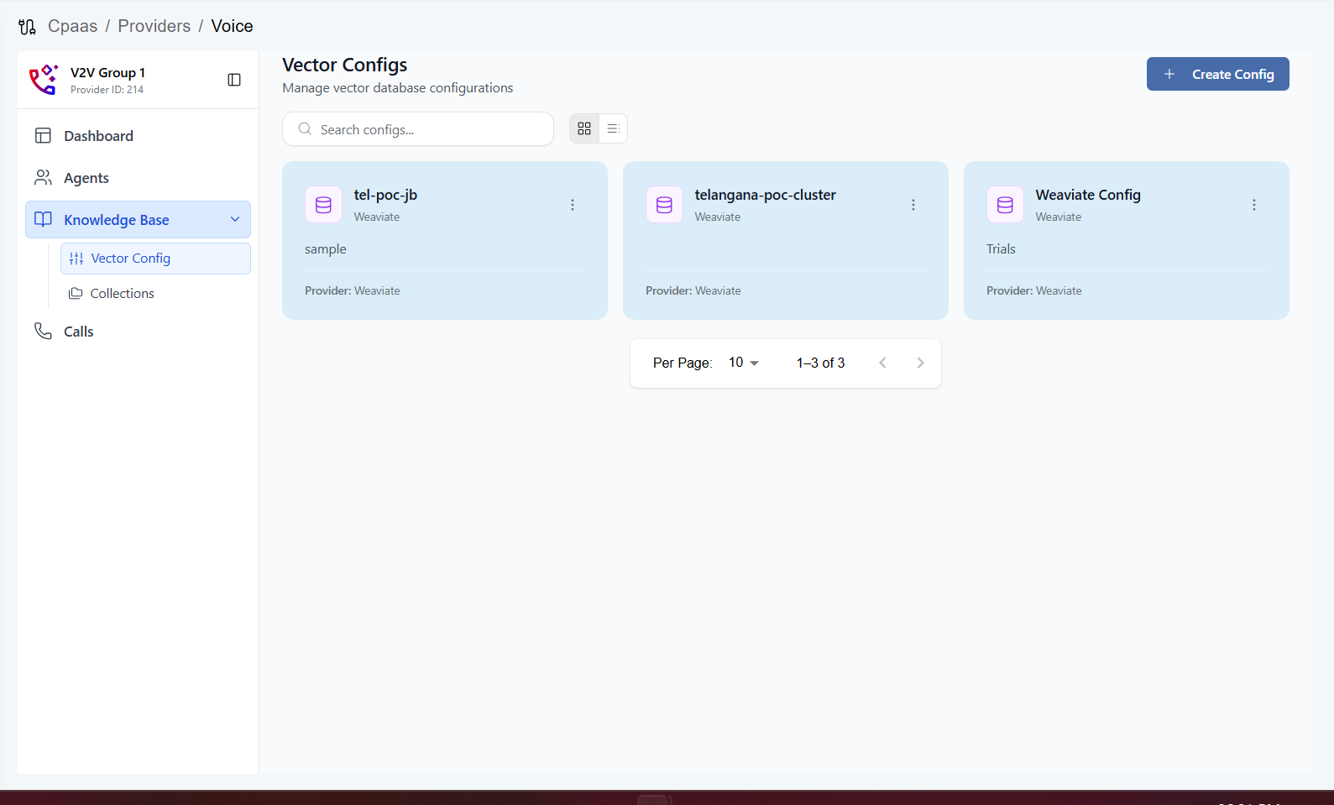
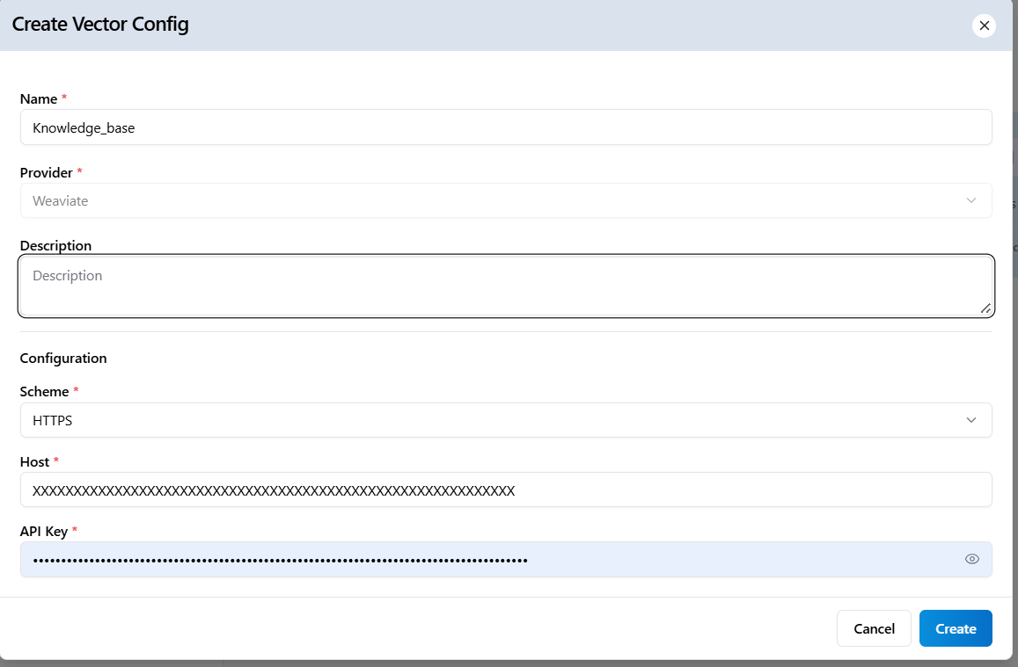

- Feature 5: Compliance and Observability Infrastructure - Pain Relieved: Regulatory risk
- Full call recordings with transcripts and sentiment analysis for audit trails. System prompts enforce hard constraints on prohibited topics, required disclosures, and escalation triggers. Real-time monitoring dashboards for agent behavior, token usage, and compliance metrics.
- Impact: Compliance breach rates dropped by 90% through consistent policy application, required disclosures, and appropriate escalations based on predefined rules
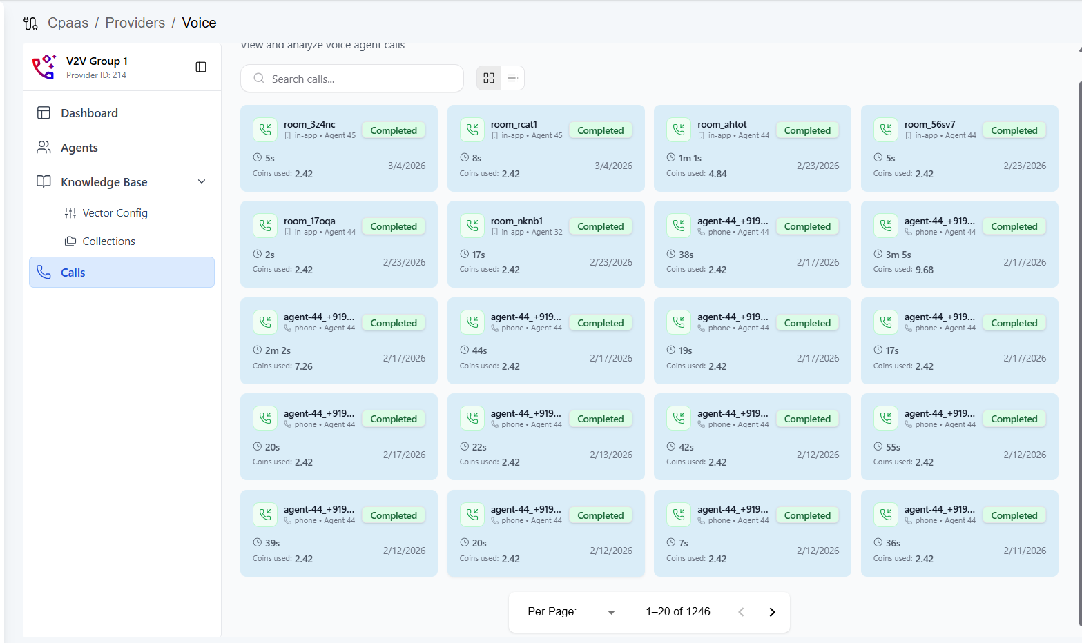
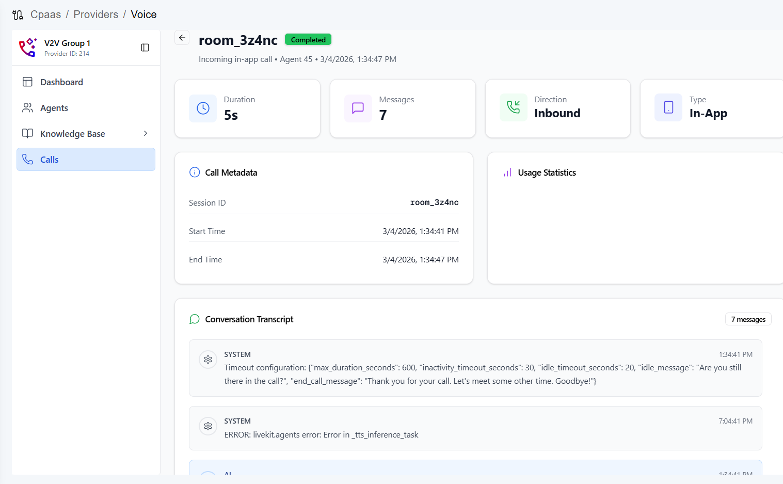

• Implementation Approach:
- Timeline: 8-10 weeks total. Week 1-2: Infrastructure deployment in client VPC and provider API integration. Week 3-4: Knowledge base upload and vectorization. Week 5-6: Agent configuration, prompt engineering, guardrail definition. Week 7: Internal testing and QA. Week 8: Phased production rollout from 10% to 100% traffic.
- Integration complexity: Medium-High. Required CRM integration for customer data lookup and session logging. Built custom WebSocket connector for Exotel to meet Indian PSTN data locality requirements. Configured multi-provider failover logic for STT and TTS. Implemented VPC deployment, audit logging, and call recording infrastructure meeting banking and healthcare regulations.
- Change management strategy: Executive briefings on ROI projections and compliance benefits. 2-week training program for supervisors on dashboard usage and monitoring. Phased customer rollout starting with low-complexity use cases (information lookup), then appointment scheduling, then collections. Redeployed first-line agents to escalation handling, framing AI as augmentation rather than replacement.
• Technical Capabilities & Architecture:
- Real-time communication layer: LiveKit for low-latency audio streaming and agent-to-agent coordination
- Speech-to-Text: Multi-provider support (Deepgram, Azure Speech, Gladia, Sarvam AI) with language-based routing
- Language Models: OpenAI GPT-4, Google Gemini, Groq, client-selectable based on cost and performance trade-offs
- Text-to-Speech: Google Cloud TTS, ElevenLabs, Deepgram with voice cloning and regional accent support
- Telephony: Exotel (India PSTN compliance), Twilio (international) with custom WebSocket integration
- Vector Database: Weaviate for knowledge base embedding, retrieval, and real-time context injection
- State Management: Within-call memory maintains conversation history and extracted entities; cross-call memory stores session summaries and outcomes in CRM
________________________________________________________________________________
4. OUTCOME (Quantified Results)
• Measurable Results:
Metric | Before | After | Improvement
Average wait time | 45-90 seconds | 0 seconds | 100% reduction
Call throughput capacity | Baseline | 10x baseline | 900% increase
Appointment scheduling time | 4-6 minutes | 90 seconds | 70% reduction
Information lookup time | 2-3 minutes | 30 seconds | 83% reduction
Response accuracy | 70-85% | 95%+ | +15-30 points

- Cost savings: Personnel costs declined by 60-75% for routine interaction categories. Infrastructure costs shifted from fixed seat licenses to per-minute billing (Rs 2-4 per minute based on provider selection). 10x volume growth achieved without proportional staffing increases.
- Time saved: Appointment scheduling reduced from 4-6 minute calls to 90-second interactions (70% reduction). Information lookup queries resolved in 30 seconds versus 2-3 minutes with human navigation.
- Quality improvement: Response accuracy improved from 70-85% to 95%+. Compliance breach rate reduced by 90% through consistent policy application. Caller sentiment: 87% positive or neutral for agent-handled interactions.
• Strategic Impact:
- Revenue growth: Zero queue abandonment eliminated revenue leakage from customers hanging up during wait times. 40% increase in addressable customer base through multilingual support in 8 additional languages. 24/7 availability captured after-hours and weekend demand previously lost, estimated 15-20% revenue uplift from extended accessibility.
- Margin expansion: Cost per interaction reduced from $3-5 (human agent) to $0.50-1.20 (AI agent including all provider costs). Eliminated need for emergency overstaffing during demand spikes.
- Compliance improvement: 100% audit trail coverage with full call recordings, transcripts, and AI-generated summaries for regulatory review. Automated enforcement of required statements in banking and healthcare interactions. No missed escalations through rules-based routing.
• Human Impact:
- Reduced stress: Operations teams shifted from firefighting mode to strategic optimization, using real-time dashboards and sentiment analysis to identify systemic issues
- Improved collaboration: Human agents repositioned from repetitive interactions to complex problem-solving and escalation handling, increasing job satisfaction and reducing turnover
- Leadership confidence: Predictable cost structure and compliance infrastructure enabled aggressive growth strategies without operational risk
• Client Testimonial:
"We went from capacity-constrained to capacity-unlimited. The AI voice platform did not just reduce costs. It unlocked growth we could not achieve with traditional call centers. We are now serving 10x the volume with better quality, regulatory compliance, and customer satisfaction than ever before. This is not automation. This is transformation."
- Chief Operations Officer, Multi-Vertical Enterprise
________________________________________________________________________________
EXECUTIVE SUMMARY SNAPSHOT
Problem: Contact center infrastructure consumed 40-60% of operational budget, capped scalability at existing staffing levels, and failed to deliver multilingual, 24/7 service, creating a strategic ceiling on growth.
Solution: Deployed Adya AI Voice Platform, an enterprise multi-agent system for autonomous voice interactions with owned intelligence infrastructure, multilingual real-time processing (12+ languages), and full compliance governance.
Outcome: Achieved 60-75% cost reduction, 10x throughput capacity increase, 40% market expansion through multilingual support, 95%+ response accuracy, and 90% compliance breach reduction, transforming contact center from cost center to competitive advantage.

